JSONRecharge API Document

URL : http://api.mrechargesystem.com/ReCharge/JsonRechargeApi.asmx

Method Name : Recharge
Url : http://api.mrechargesystem.com/ReCharge/JsonRechargeApi.asmx?op=Recharge

Parameters:

- Source = (API) For API Request
- MobileNo = Website Register Mobile No

- circle=circle Code (see the circle list below)
- ServiceName=ServiceName(see the Servicelist below)
- RechargeType= RR/STV/DTH/PP/BP
- RechargeNumber= RechargeMobileNumber/AccountNumber
- Amount=Recharge Amount
- PinNumber=Pinno
- TransId=Client Unique Id

Recharge Parameter Description:

- Mob =this is website Recharge Mobile Number which is used for Authentication.

- Recharge Type = (RR| STV|DTH|PP) Recharge Type for Recharge Request.

- Service Name = Please Send Service full Name of Operators (See APPENDIXI Service Operator Page)

- Recharge Number= please send Recharge mobile No or Digital TV Number.

- Recharge Amount = Please Send Recharge Amount.

- Pin Number = This is website register pin number which is used for authentication.

- Source Please send (API) Keyword Is Source Parameter

- Circle= Please send circle code here (See APPENDIXI Circle Code)

Recharge Type:

- Recharge = RR

- Special Recharge = STV

- Digital T.V. Recharge = DTH

- Postpaid Recharge = PP

Replay Getting From Recharge Request:

Reply:

When the recharge request successfully submitted then your request is in pending mode This type of reply is coming:
{
"Status":"0",
"TransId":"4971",
"Balance":null,
"ServiceName":null,
"Amount":null,
"MobileNo":null,
"Message":"Your Request have been Processed"
}

When the recharge request directly fail then below reply coming:
{
"Status":"1",
"TransId":"4971",
"Balance":null,
"ServiceName":null,
"Amount":null,
"MobileNo":null,
"Message":"Your Request have been fail"
}

In some Case Its Directly Recharge Success then replay is coming
{
"Status":"2",
"TransId":"4971",
"Balance":null,
"ServiceName":null,
"Amount":null,
"MobileNo":null,
"Message":"Your Request has been Success”
}

Some in fail case, other fail message will also come like

- Mobile number must not be less than 10 digits

- Sorry...Invalid Mobile Number Or Pin Number

- Sorry..!! Your Service is Temporarily Unavailable Contact Your Distributor for Further Assistance.

- Insufficient balance for this Recharge

- Invalid Recharge Amount

- Service Unavailable Gateway Problem.

- You can't send same Recharge Request for 20 min.

- You cannot request for recharge because your distributor have no balance.

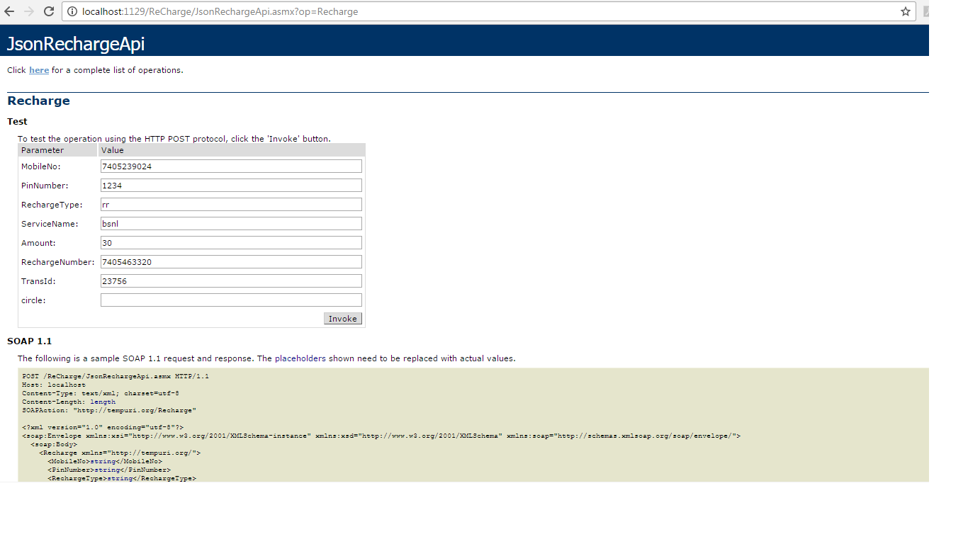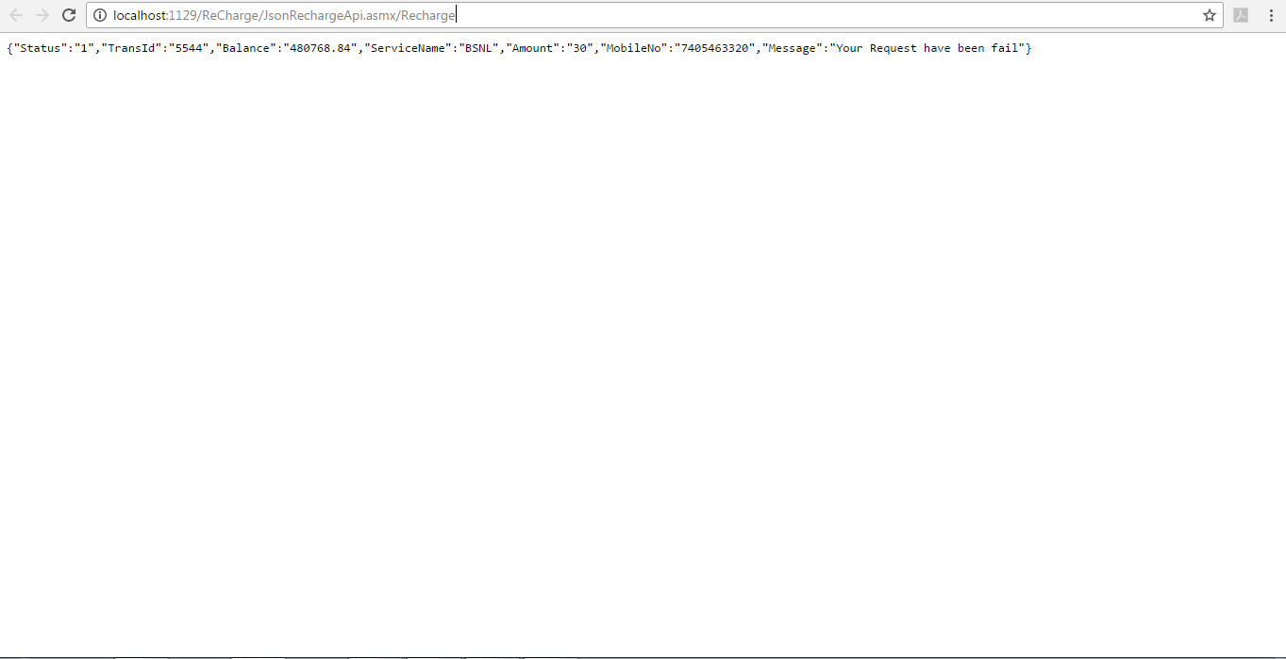

Call Back Url Parameter:(if transaction is in pending we call this url to update on your website)

Please provide the status url for the recharge request to the Recharge Website.

• Transtype = “ s” for success
“ f” for failure

- Txid = operater tansaction Id

- accounted = Your unique Recharge Id

Sample Response Url Format:

http://www.yourdomain.com/pagename?accountId=2&txid=2323&transtype=s

Status Check Url Parameter with your Recharge Id:

Method Name : StatusCheckByRequestId
Url : http://free.mrechargesystem.com/ReCharge/JsonRechargeApi.asmx?op=StatusCheckByRequestId

You can call the status check URL to get status of requested Unique

Recharge ID, You need to pass the requested Id

- MobileNo=this is website Recharge Mobile Number which is used for Authentication.

- Command= mytxid Is a command Name for check status of recharge unique id

- PinNumber= This is website register pin number which is used for authentication.
- RequestId=YourSystem UniqueId.

- Source please send (API) Keyword Is Source Parameter

Response Coming from check Transaction Status :

Fail

{"Status":"1","OperatorId":"","ServiceName":"Airtel","Amount":"100.00 Rs ","MobileNo":" 1234567890","Message":null}

Success

{"Status":"2","OperatorId":"XXXX","ServiceName":" Airtel ","Amount":"500.00 Rs ","MobileNo":" 1234567890","Message":null}

Pending
{"Status":"0","OperatorId":"XXXX","ServiceName":" Airtel ","Amount":"500.00 Rs ","MobileNo":" 1234567890","Message":null}

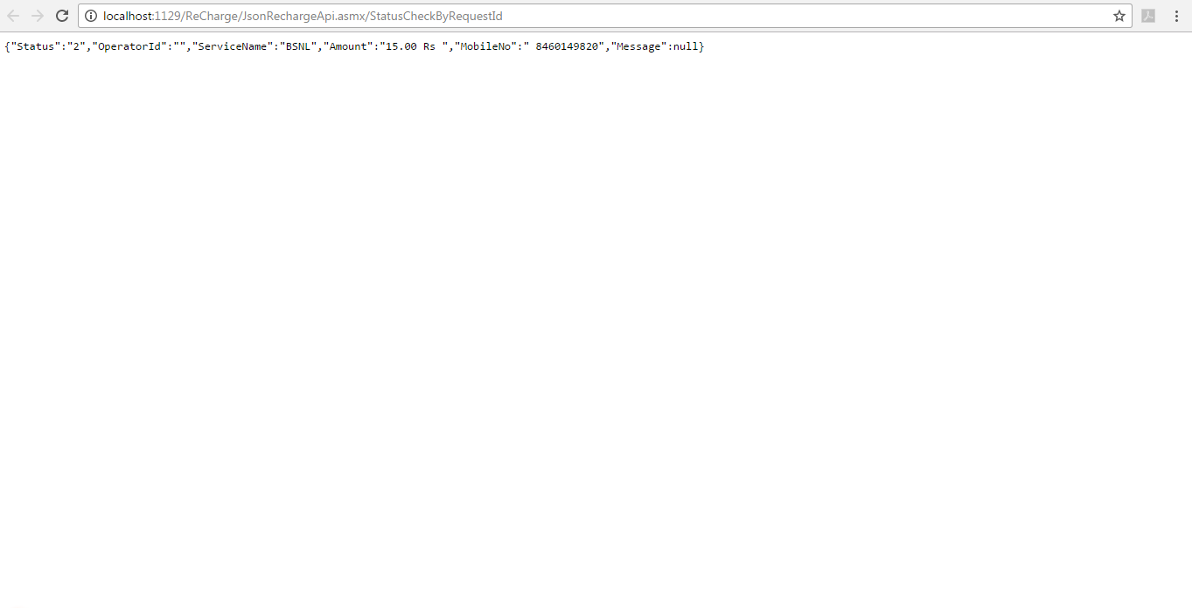

Status Check Url Parameter with Our Transaction Id:

You can call the status check url to get status of our unique Transaction Id,

You need to pass the requested with the url below

Method Name : StatusCheckByRefId
Url : http://free.mrechargesystem.com/ReCharge/JsonRechargeApi.asmx?op=StatusCheckByRefId

- MobileNo=this is website Recharge Mobile Number which is used for Authentication.

- Command= txid Is a command Name for check status of recharge unique id

- PinNumber= This is website register pin number which is used for authentication.
- RefId=our System UniqueId.

- Source please send (API) Keyword Is Source Parameter

Response Coming from check Transaction Status:

Fail

{"Status":"1","OperatorId":"","ServiceName":"Airtel","Amount":"100.00 Rs ","MobileNo":" 1234567890","Message":null}

Success

{"Status":"2","OperatorId":"XXXX","ServiceName":" Airtel ","Amount":"500.00 Rs ","MobileNo":" 1234567890","Message":null}

Pending
{"Status":"0","OperatorId":"XXXX","ServiceName":" Airtel ","Amount":"500.00 Rs ","MobileNo":" 1234567890","Message":null}

APPENDIXI

SERVICE

OPERATOR

Operator

MobileOperators

Airtel

Vodafone

BSNL

Reliance

RelianceCDMA

Aircel

Idea

TataIndicom

Loop

Docomo

VirginCDMA

Virgin

MTNL

MTS

Uninor

Videocon

DTHOperators

TataSky

RelianceDigitalTV

VideoconD2h

AirtelDigitalTV

DishTV

SunDirect

 | APPENDIXI
 | CIRCLE CODE
Operator |  | Short Name Code
Andhra Pradesh & Telegana |  | 1
Assam |  | 2
Bihar & Jharkhand |  | 3
Chennai |  | 4
Delhi |  | 5
Gujarat & Daman & Diu |  | 6
Haryana |  | 7
Himachal Pradesh |  | 8
Jammu Kashmir |  | 9
Karnataka |  | 10
Kerala & Lakshadweep |  | 11
Kolkata |  | 12
Madhya Pradesh & Chhattisgarh |  | 13
Maharashtra & Goa |  | 14
Mumbai |  | 15
North East |  | 16
Odisha |  | 17
Punjab |  | 18
Rajasthan |  | 19
Tamil Nadu |  | 20
Uttar Pradesh ‐ East |  | 21
Uttar Pradesh ‐ West & Uttarakhand |  | 22
West Bengal |  | 23
Uttaranchal |  | 24

